# SpringMVC概述

## 三层架构

表现层：SpringMVC

业务层（Service）：Spring

持久层（Dao）：Mybatis

## MVC设计模型

模型（Model）

视图（View）

控制器（Controller）

## SpringMVC介绍

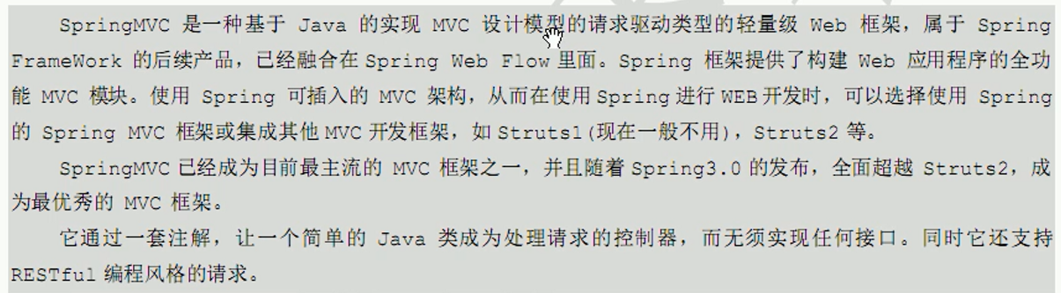

SpringMVC组件

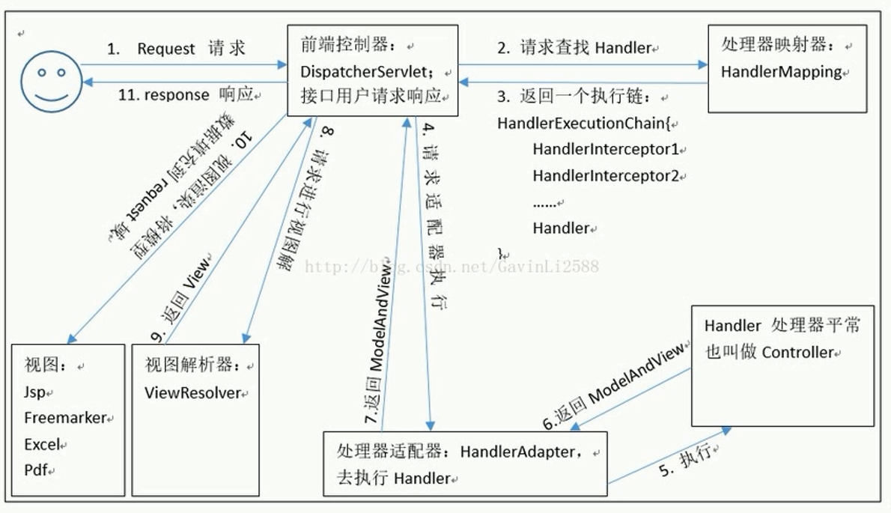

## 入门程序

目的：前端页面发送请求后，后台进行处理返回成功页面

流程：

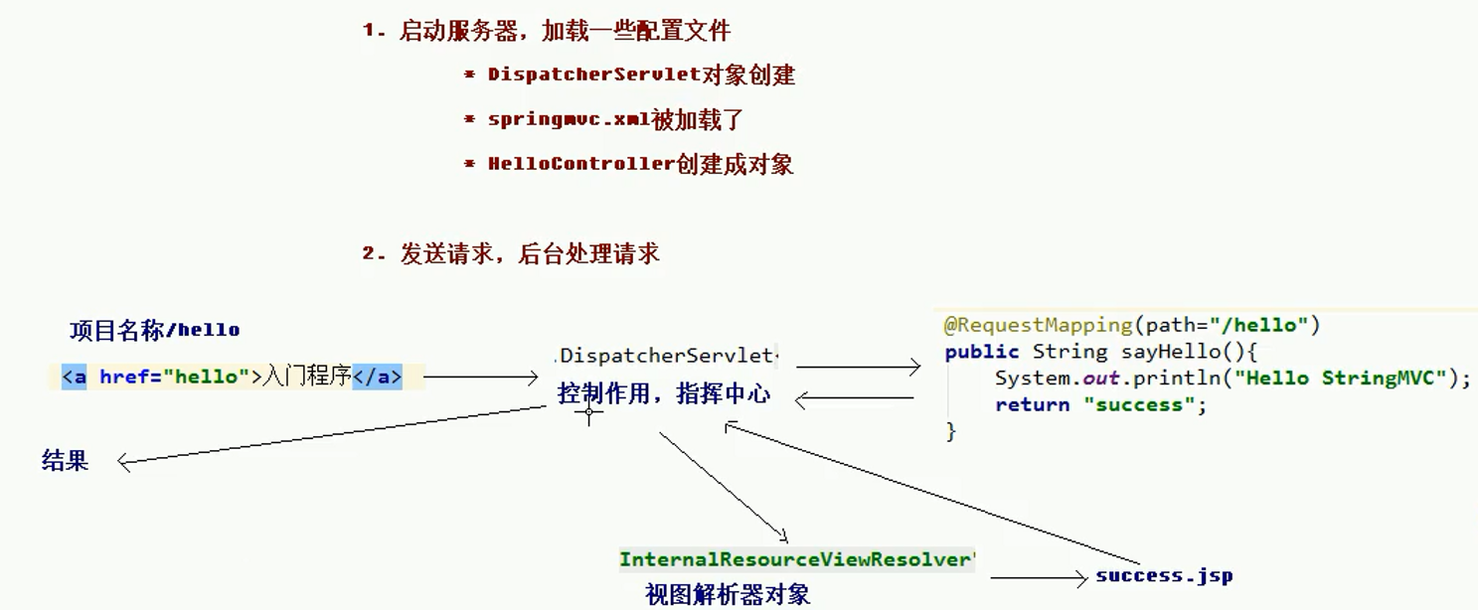

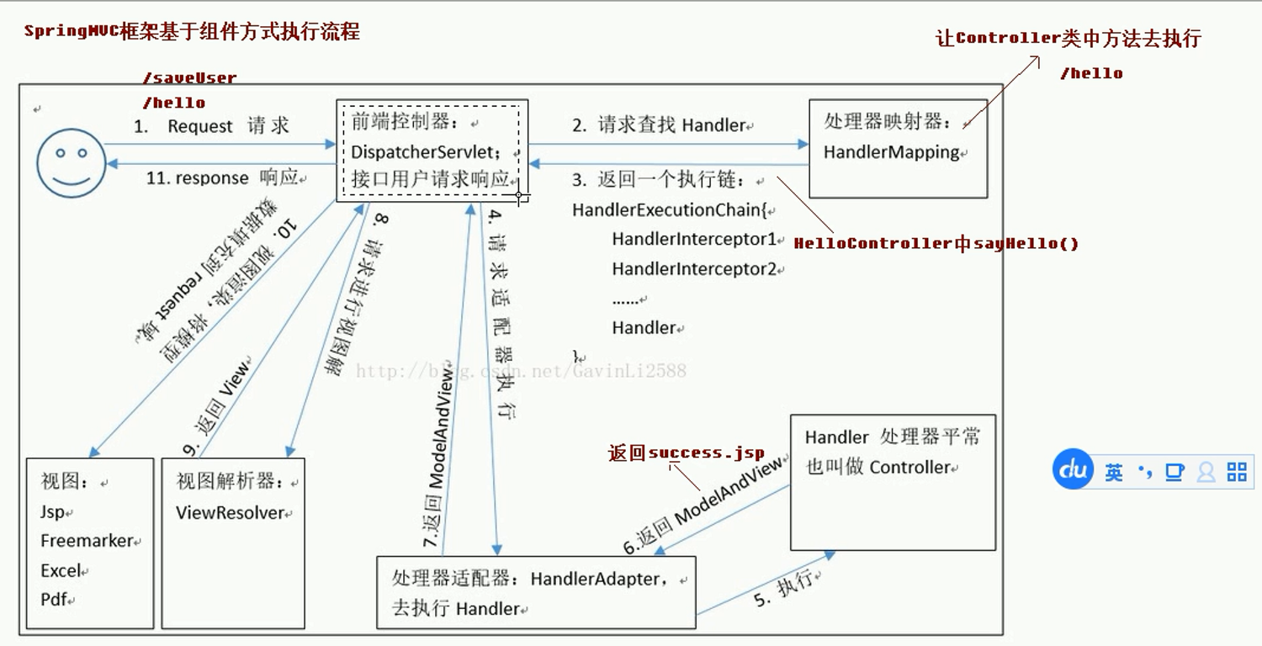

### 步骤

#### 搭建环境

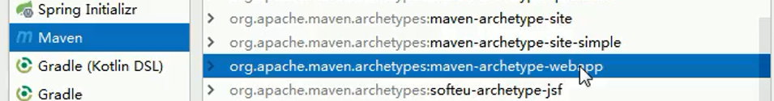

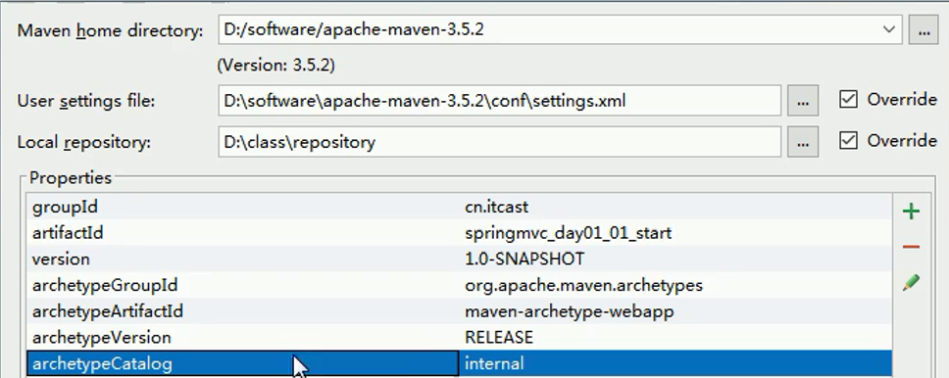

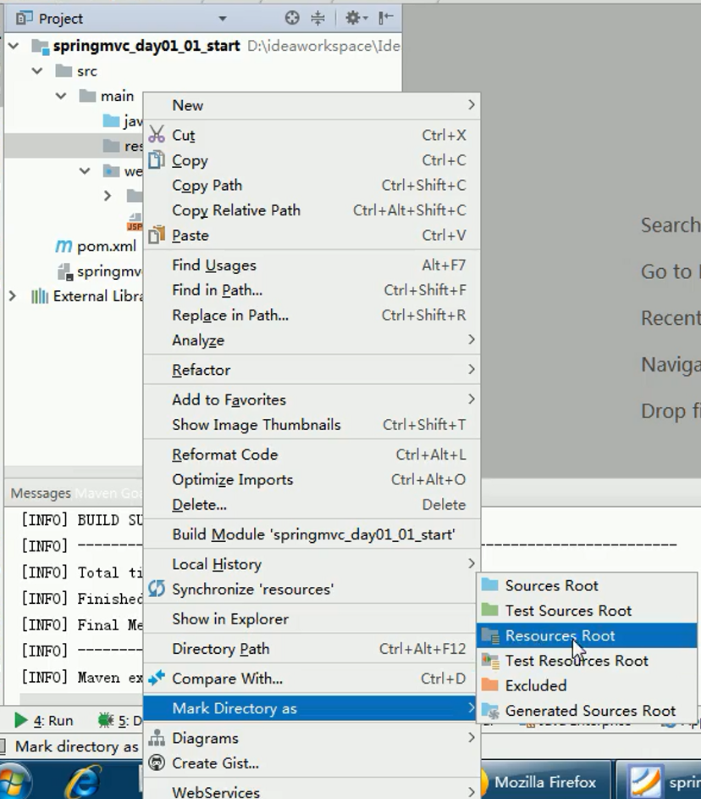

#### 目录结构

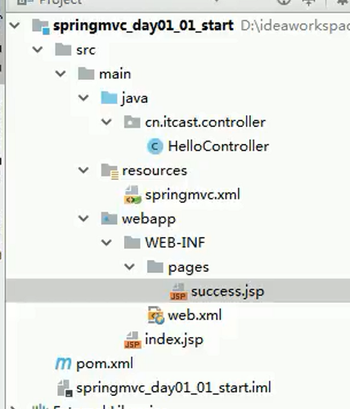

#### 文件

pom.xml

<?xml version="1.0" encoding="UTF-8"?>

<project xmlns="http://maven.apache.org/POM/4.0.0" xmlns:xsi="http://www.w3.org/2001/XMLSchema-instance"

xsi:schemaLocation="http://maven.apache.org/POM/4.0.0 http://maven.apache.org/xsd/maven-4.0.0.xsd">

<modelVersion>4.0.0</modelVersion>

<groupId>cn.itcast</groupId>

<artifactId>springmvc_day01_01_start</artifactId>

<version>1.0-SNAPSHOT</version>

<packaging>war</packaging>

<name>springmvc_day01_01_start Maven Webapp</name>

<!-- FIXME change it to the project's website -->

<url>http://www.example.com</url>

<properties>

<project.build.sourceEncoding>UTF-8</project.build.sourceEncoding>

<maven.compiler.source>1.8</maven.compiler.source>

<maven.compiler.target>1.8</maven.compiler.target>

<spring.version>5.0.2.RELEASE</spring.version>

</properties>

<dependencies>

<dependency>

<groupId>org.springframework</groupId>

<artifactId>spring-context</artifactId>

<version>${spring.version}</version>

</dependency>

<dependency>

<groupId>org.springframework</groupId>

<artifactId>spring-web</artifactId>

<version>${spring.version}</version>

</dependency>

<dependency>

<groupId>org.springframework</groupId>

<artifactId>spring-webmvc</artifactId>

<version>${spring.version}</version>

</dependency>

<dependency>

<groupId>javax.servlet</groupId>

<artifactId>servlet-api</artifactId>

<version>2.5</version>

<scope>provided</scope>

</dependency>

<dependency>

<groupId>javax.servlet.jsp</groupId>

<artifactId>jsp-api</artifactId>

<version>2.0</version>

<scope>provided</scope>

</dependency>

</dependencies>

<build>

<finalName>springmvc_day01_01_start</finalName>

<pluginManagement><!-- lock down plugins versions to avoid using Maven defaults (may be moved to parent pom) -->

<plugins>

<plugin>

<artifactId>maven-clean-plugin</artifactId>

<version>3.0.0</version>

</plugin>

<!-- see http://maven.apache.org/ref/current/maven-core/default-bindings.html#Plugin_bindings_for_war_packaging -->

<plugin>

<artifactId>maven-resources-plugin</artifactId>

<version>3.0.2</version>

</plugin>

<plugin>

<artifactId>maven-compiler-plugin</artifactId>

<version>3.7.0</version>

</plugin>

<plugin>

<artifactId>maven-surefire-plugin</artifactId>

<version>2.20.1</version>

</plugin>

<plugin>

<artifactId>maven-war-plugin</artifactId>

<version>3.2.0</version>

</plugin>

<plugin>

<artifactId>maven-install-plugin</artifactId>

<version>2.5.2</version>

</plugin>

<plugin>

<artifactId>maven-deploy-plugin</artifactId>

<version>2.8.2</version>

</plugin>

</plugins>

</pluginManagement>

</build>

</project>

web.xml

<!DOCTYPE web-app PUBLIC

"-//Sun Microsystems, Inc.//DTD Web Application 2.3//EN"

"http://java.sun.com/dtd/web-app_2_3.dtd" >

<web-app>

<display-name>Archetype Created Web Application</display-name>

<!--配置前端控制器-->

<servlet>

<servlet-name>dispatcherServlet</servlet-name>

<servlet-class>org.springframework.web.servlet.DispatcherServlet</servlet-class>

<init-param>

<param-name>contextConfigLocation</param-name>

<param-value>classpath:springmvc.xml</param-value>

</init-param>

<load-on-startup>1</load-on-startup>

</servlet>

<servlet-mapping>

<servlet-name>dispatcherServlet</servlet-name>

<url-pattern>/</url-pattern>

</servlet-mapping>

</web-app>

springmvc.xml

<?xml version="1.0" encoding="UTF-8"?>

<beans xmlns="http://www.springframework.org/schema/beans"

xmlns:mvc="http://www.springframework.org/schema/mvc"

xmlns:context="http://www.springframework.org/schema/context"

xmlns:xsi="http://www.w3.org/2001/XMLSchema-instance"

xsi:schemaLocation="

http://www.springframework.org/schema/beans

http://www.springframework.org/schema/beans/spring-beans.xsd

http://www.springframework.org/schema/mvc

http://www.springframework.org/schema/mvc/spring-mvc.xsd

http://www.springframework.org/schema/context

http://www.springframework.org/schema/context/spring-context.xsd">

<!-- 开启注解扫描 -->

<context:component-scan base-package="cn.itcast"/>

<!-- 视图解析器对象 -->

<bean id="internalResourceViewResolver" class="org.springframework.web.servlet.view.InternalResourceViewResolver">

<property name="prefix" value="/WEB-INF/pages/"/>

<property name="suffix" value=".jsp"/>

</bean>

<!-- 开启SpringMVC框架注解的支持 -->

<mvc:annotation-driven"/>

</beans>

HelloController.java

import org.springframework.stereotype.Controller;

import org.springframework.web.bind.annotation.RequestMapping;

// 控制器类

@Controller

@RequestMapping(path="/user")

public class HelloController {

/**

* 入门案例

* @return

*/

@RequestMapping(path="/hello")

public String sayHello(){

System.out.println("Hello StringMVC");

return "success";

}

/**

* RequestMapping注解

* @return

*/

@RequestMapping(value="/testRequestMapping",params = {"username=heihei"},headers = {"Accept"})

public String testRequestMapping(){

System.out.println("测试RequestMapping注解...");

return "success";

}

}

success.jsp

<%@ page contentType="text/html;charset=UTF-8" language="java" isELIgnored="false" %>

<html>

<head>

<title>Title</title>

</head>

<body>

<h3>入门成功</h3>

${ msg }

${sessionScope}

</body>

</html>

index.jsp

<%@ page contentType="text/html;charset=UTF-8" language="java" %>

<html>

<head>

<title>Title</title>

</head>

<body>

<h3>入门程序</h3>

<%--

<a href="hello">入门程序</a>

--%>

</body>

</html>

# 参数绑定和自定义类型转换

## 参数绑定

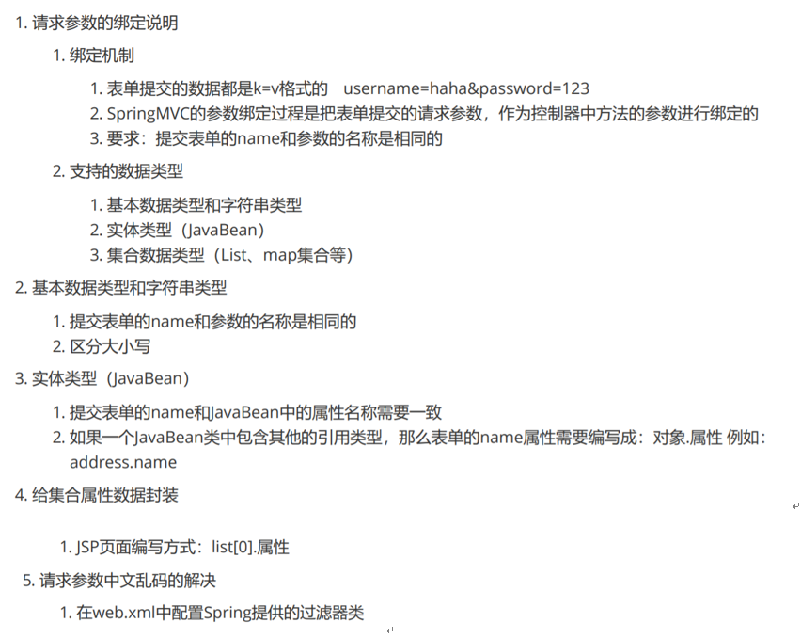

### 基本数据类型绑定

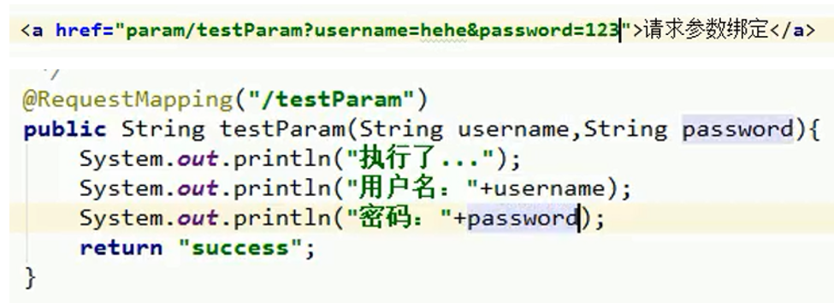

### 实体类型绑定

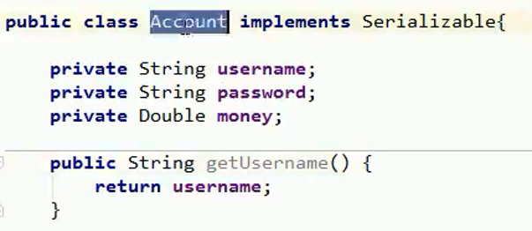

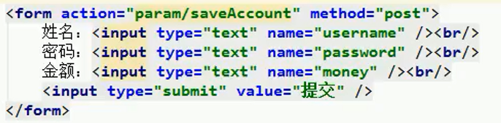

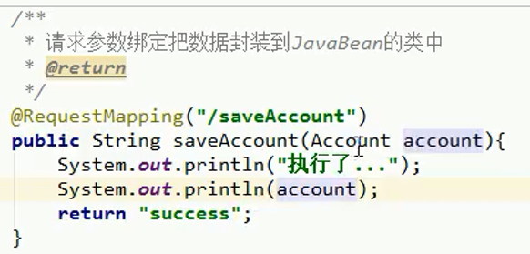

### 实体类型绑定2

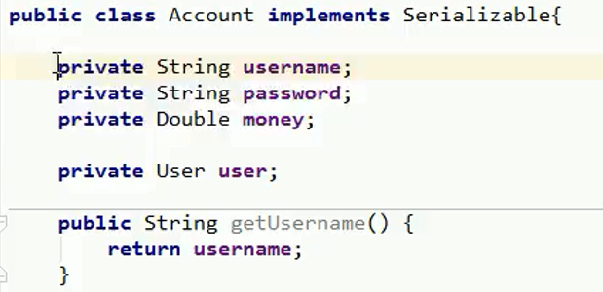

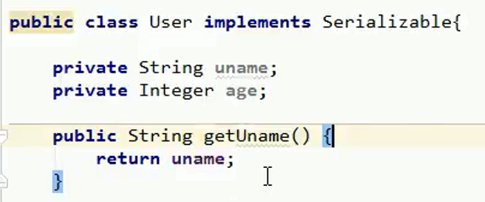

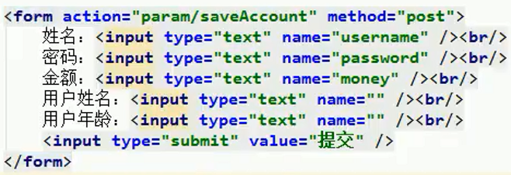

### 集合类型绑定

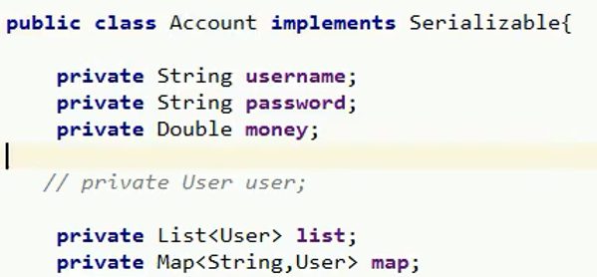

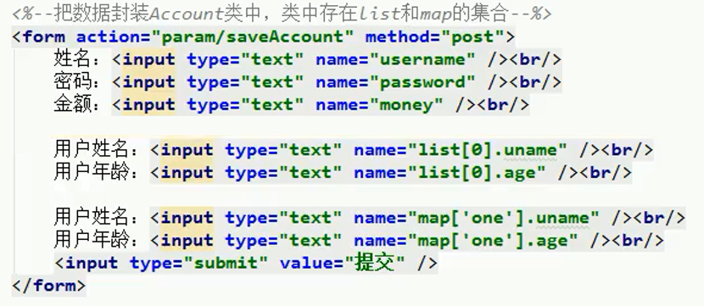

## 配置解决中文乱码的过滤器

web.xml中配置过滤器

<!--配置解决中文乱码的过滤器-->

<filter>

<filter-name>characterEncodingFilter</filter-name>

<filter-class>org.springframework.web.filter.CharacterEncodingFilter</filter-class>

<init-param>

<param-name>encoding</param-name>

<param-value>UTF-8</param-value>

</init-param>

</filter>

<filter-mapping>

<filter-name>characterEncodingFilter</filter-name>

<url-pattern>/*</url-pattern>

</filter-mapping>

## 自定义转换器

例如：将字符串2020-01-03转换为日期类型

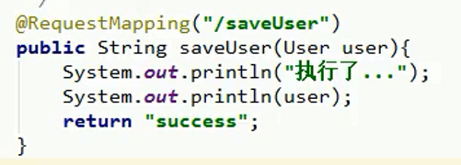

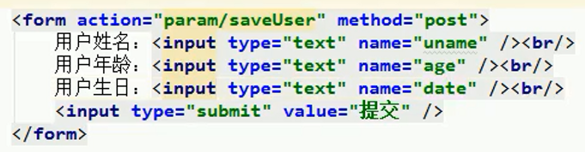

创建转换器类

import org.springframework.core.convert.converter.Converter;

import java.text.DateFormat;

import java.text.SimpleDateFormat;

import java.util.Date;

/**

* 把字符串转换日期

*/

public class StringToDateConverter implements Converter<String,Date>{

/**

* String source 传入进来字符串

* @param source

* @return

*/

public Date convert(String source) {

// 判断

if(source == null){

throw new RuntimeException("请您传入数据");

}

DateFormat df = new SimpleDateFormat("yyyy-MM-dd");

try {

// 把字符串转换日期

return df.parse(source);

} catch (Exception e) {

throw new RuntimeException("数据类型转换出现错误");

}

}

}

在springmvc.xml中配置转换器

<!--配置自定义类型转换器-->

<bean id="conversionService" class="org.springframework.context.support.ConversionServiceFactoryBean">

<property name="converters">

<set>

<bean class="cn.itcast.utils.StringToDateConverter"/>

</set>

</property>

</bean>

<mvc:annotation-driven conversion-service="conversionService"/>

## 使用servlet原生API



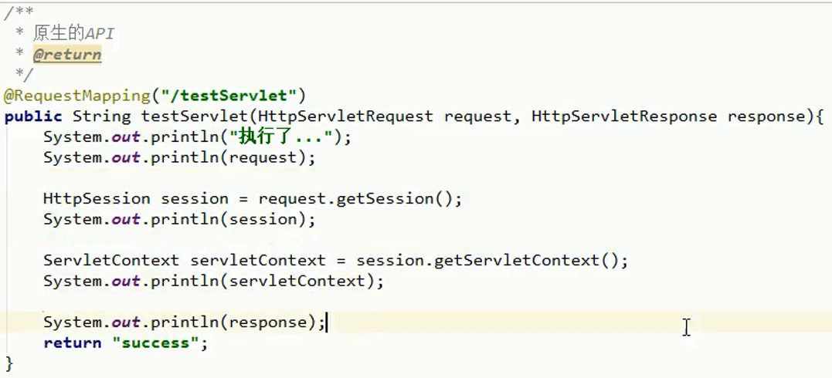

# 常用注解

## 常用注解

* RequestParam：绑定对应名称参数
* RequestBody：获取请求体内容（###=***&###=***），不适用get方法
* PathVaribale：获取/test/{id}中的id属性
* RequestHeader：获取消息头
* CookieValue：获取Cookie值
* ModelAttribute：该标注的方法会先于其他方法执行
* SessionAttribute：设置session值来使全局对象都可以使用

import cn.itcast.domain.User;

import org.springframework.stereotype.Controller;

import org.springframework.ui.Model;

import org.springframework.ui.ModelMap;

import org.springframework.web.bind.annotation.*;

import org.springframework.web.bind.support.SessionStatus;

import javax.servlet.http.HttpServletRequest;

import javax.servlet.http.HttpServletResponse;

import java.io.IOException;

import java.util.Date;

import java.util.Map;

/**

* 常用的注解

*/

@Controller

@RequestMapping("/anno")

@SessionAttributes(value={"msg"}) // 把msg=美美存入到session域对中

public class AnnoController {

@RequestMapping("/testRequestParam")

public String testRequestParam(@RequestParam(name="name") String username){

System.out.println("执行了...");

System.out.println(username);

return "success";

}

/**

* 获取到请求体的内容

* @return

*/

@RequestMapping("/testRequestBody")

public String testRequestBody(@RequestBody String body){

System.out.println("执行了...");

System.out.println(body);

return "success";

}

/**

* PathVariable注解

* @return

*/

@RequestMapping(value="/testPathVariable/{sid}")

public String testPathVariable(@PathVariable(name="sid") String id){

System.out.println("执行了...");

System.out.println(id);

return "success";

}

/**

* 获取请求头的值

* @param header

* @return

*/

@RequestMapping(value="/testRequestHeader")

public String testRequestHeader(@RequestHeader(value="Accept") String header, HttpServletRequest request,HttpServletResponse response) throws IOException {

System.out.println("执行了...");

System.out.println(header);

// return "success";

// response.sendRedirect(request.getContextPath()+"/anno/testCookieValue");

return "redirect:/param.jsp";

}

/**

* 获取Cookie的值

* @return

*/

@RequestMapping(value="/testCookieValue")

public String testCookieValue(@CookieValue(value="JSESSIONID") String cookieValue){

System.out.println("执行了...");

System.out.println(cookieValue);

return "success";

}

/**

* ModelAttribute注解

* @return

*/

@RequestMapping(value="/testModelAttribute")

public String testModelAttribute(@ModelAttribute("abc") User user){

System.out.println("testModelAttribute执行了...");

System.out.println(user);

return "success";

}

@ModelAttribute

public void showUser(String uname, Map<String,User> map){

System.out.println("showUser执行了...");

// 通过用户查询数据库（模拟）

User user = new User();

user.setUname(uname);

user.setAge(20);

user.setDate(new Date());

map.put("abc",user);

}

/**

* 该方法会先执行

@ModelAttribute

public User showUser(String uname){

System.out.println("showUser执行了...");

// 通过用户查询数据库（模拟）

User user = new User();

user.setUname(uname);

user.setAge(20);

user.setDate(new Date());

return user;

}

*/

/**

* SessionAttributes的注解

* @return

*/

@RequestMapping(value="/testSessionAttributes")

public String testSessionAttributes(Model model){

System.out.println("testSessionAttributes...");

// 底层会存储到request域对象中

model.addAttribute("msg","美美");

return "success";

}

/**

* 获取值

* @param modelMap

* @return

*/

@RequestMapping(value="/getSessionAttributes")

public String getSessionAttributes(ModelMap modelMap){

System.out.println("getSessionAttributes...");

String msg = (String) modelMap.get("msg");

System.out.println(msg);

return "success";

}

/**

* 清除

* @param status

* @return

*/

@RequestMapping(value="/delSessionAttributes")

public String delSessionAttributes(SessionStatus status){

System.out.println("getSessionAttributes...");

status.setComplete();

return "success";

}

}

<body>

<%--常用的注解--%>

<a href="anno/testRequestParam?name=哈哈">RequestParam</a>

<br>

<form action="anno/testRequestBody" method="post">

用户姓名：<input type="text" name="username" /><br/>

用户年龄：<input type="text" name="age" /><br/>

<input type="submit" value="提交" />

</form>

<a href="anno/testPathVariable/10">testPathVariable</a>

<br>

<a href="anno/testRequestHeader">RequestHeader</a>

<br>

<a href="anno/testCookieValue">CookieValue</a>

<br>

<form action="anno/testModelAttribute" method="post">

用户姓名：<input type="text" name="uname" /><br/>

用户年龄：<input type="text" name="age" /><br/>

<input type="submit" value="提交" />

</form>

<br>

<a href="anno/testSessionAttributes">testSessionAttributes</a>

<a href="anno/getSessionAttributes">getSessionAttributes</a>

<a href="anno/delSessionAttributes">delSessionAttributes</a>

</body>

## 请求方法过滤器（HiddenHttpMethodFilter）

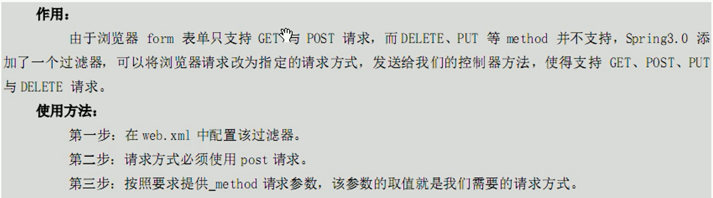

略

# restful编程风格URL

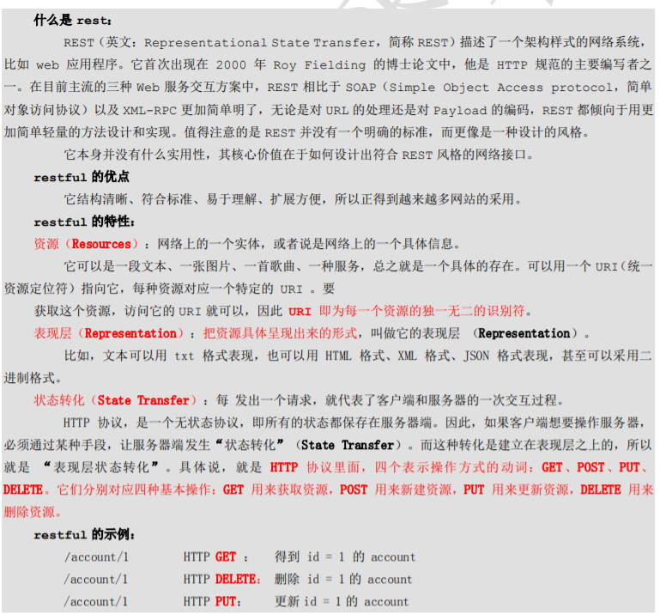

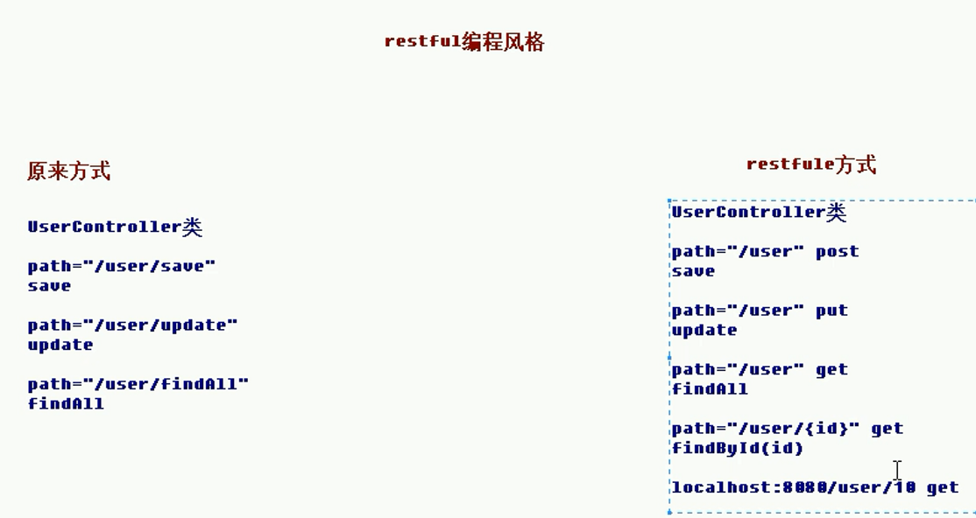

# 返回值类型和响应数据类型

## 返回值类型

### String

通过返回字符串跳转到对应的jsp页面

@RequestMapping("/testString")

public String testString(Model model){

System.out.println("testString方法执行了...");

// 模拟从数据库中查询出User对象

User user = new User();

user.setUsername("美美");

user.setPassword("123");

user.setAge(30);

// model对象

model.addAttribute("user",user);

return "success";

}

<!-- 视图解析器对象 -->

<bean id="internalResourceViewResolver" class="org.springframework.web.servlet.view.InternalResourceViewResolver">

<property name="prefix" value="/WEB-INF/pages/"/>

<property name="suffix" value=".jsp"/>

</bean>

### void

通过servlet的请求转发进行调用

三种方式

/**

* 是void

* 请求转发一次请求，不用编写项目的名称

*/

@RequestMapping("/testVoid")

public void testVoid(HttpServletRequest request, HttpServletResponse response) throws Exception {

System.out.println("testVoid方法执行了...");

// 1、编写请求转发的程序

// request.getRequestDispatcher("/WEB-INF/pages/success.jsp").forward(request,response);

// 2、重定向

// response.sendRedirect(request.getContextPath()+"/index.jsp");

// 设置中文乱码

response.setCharacterEncoding("UTF-8");

response.setContentType("text/html;charset=UTF-8");

// 3、直接会进行响应

response.getWriter().print("你好");

return;

}

### 返回ModelAndView对象

/**

* 返回ModelAndView

* @return

*/

@RequestMapping("/testModelAndView")

public ModelAndView testModelAndView(){

// 创建ModelAndView对象

ModelAndView mv = new ModelAndView();

System.out.println("testModelAndView方法执行了...");

// 模拟从数据库中查询出User对象

User user = new User();

user.setUsername("小凤");

user.setPassword("456");

user.setAge(30);

// 把user对象存储到mv对象中，也会把user对象存入到request对象

mv.addObject("user",user);

// 跳转到哪个页面

mv.setViewName("success");

return mv;

}

### 使用关键字进行转发或重定向

/**

* 使用关键字的方式进行转发或者重定向

* @return

*/

@RequestMapping("/testForwardOrRedirect")

public String testForwardOrRedirect(){

System.out.println("testForwardOrRedirect方法执行了...");

// 请求的转发

// return "forward:/WEB-INF/pages/success.jsp";

// 重定向

return "redirect:/index.jsp";

}

## 响应json数据

### 防止静态资源被前端控制器拦截

<!--前端控制器，哪些静态资源不拦截-->

<mvc:resources location="/css/" mapping="/css/**"/>

<mvc:resources location="/images/" mapping="/images/**"/>

<mvc:resources location="/js/" mapping="/js/**"/>

### 发送ajax请求

<script>

// 页面加载，绑定单击事件

$(function(){

$("#btn").click(function(){

// alert("hello btn");

// 发送ajax请求

$.ajax({

// 编写json格式，设置属性和值

url:"user/testAjax",

contentType:"application/json;charset=UTF-8",

data:'{"username":"hehe","password":"123","age":30}',

dataType:"json",

type:"post",

success:function(data){

// data服务器端响应的json的数据，进行解析

alert(data);

alert(data.username);

alert(data.password);

alert(data.age);

}

});

});

});

</script>

/**

* 模拟异步请求响应

*/

@RequestMapping("/testAjax")

public void testAjax(@RequestBody String body){

System.out.println("testAjax方法执行了...");

//打印data的内容

System.out.println(body);

}

### 响应json格式数据

springMVC将json数据封装为对象进行请求响应的转换

导入依赖

<dependency>

<groupId>com.fasterxml.jackson.core</groupId>

<artifactId>jackson-databind</artifactId>

<version>2.9.0</version>

</dependency>

<dependency>

<groupId>com.fasterxml.jackson.core</groupId>

<artifactId>jackson-core</artifactId>

<version>2.9.0</version>

</dependency>

<dependency>

<groupId>com.fasterxml.jackson.core</groupId>

<artifactId>jackson-annotations</artifactId>

<version>2.9.0</version>

</dependency>

/**

* 模拟异步请求响应

*/

@RequestMapping("/testAjax")

public @ResponseBody User testAjax(@RequestBody User user){

System.out.println("testAjax方法执行了...");

// 客户端发送ajax的请求，传的是json字符串，后端把json字符串封装到user对象中

System.out.println(user);

// 做响应，模拟查询数据库

user.setUsername("haha");

user.setAge(40);

// 做响应

return user;

}

# 文件上传

## 传统方式 & SpringMVC方式

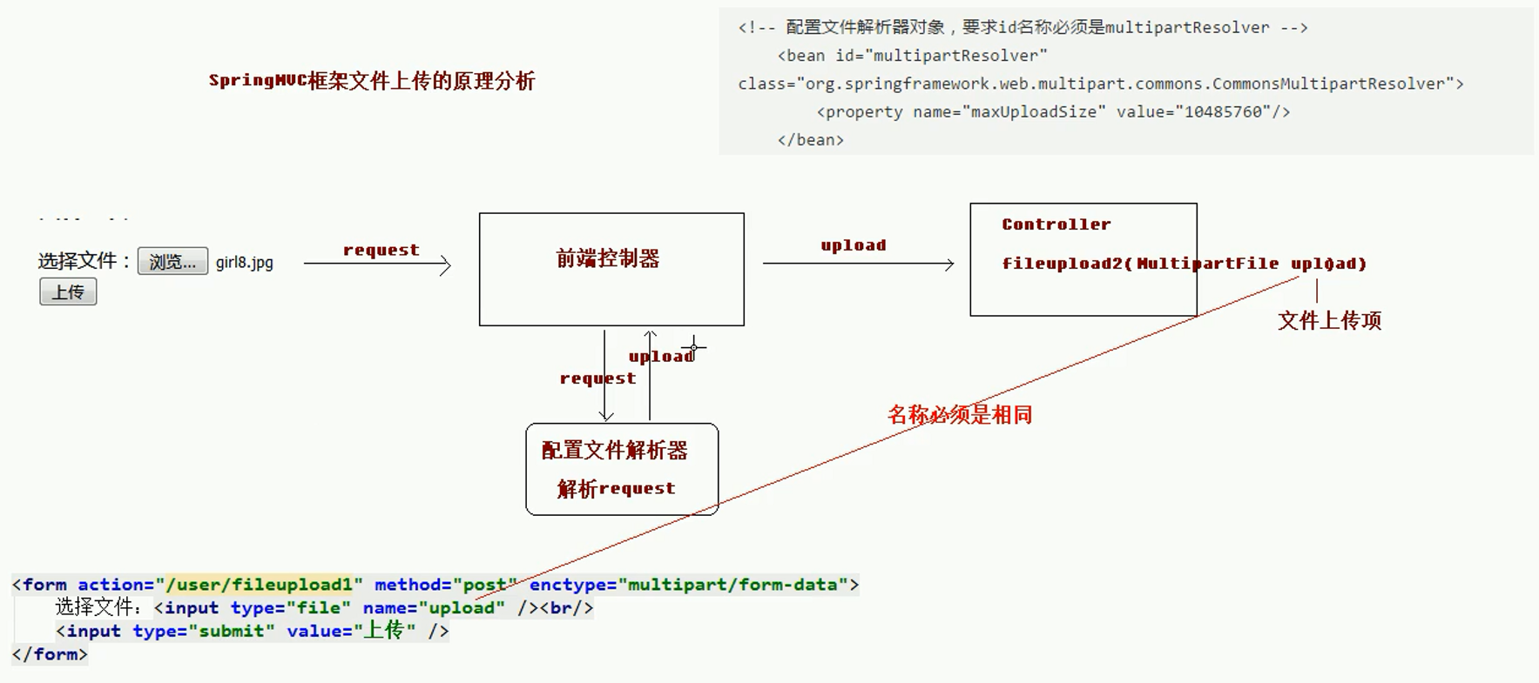

导入依赖

<dependency>

<groupId>commons-fileupload</groupId>

<artifactId>commons-fileupload</artifactId>

<version>1.3.1</version>

</dependency>

<dependency>

<groupId>commons-io</groupId>

<artifactId>commons-io</artifactId>

<version>2.4</version>

</dependency>

<dependency>

<groupId>com.sun.jersey</groupId>

<artifactId>jersey-core</artifactId>

<version>1.18.1</version>

</dependency>

<dependency>

<groupId>com.sun.jersey</groupId>

<artifactId>jersey-client</artifactId>

<version>1.18.1</version>

</dependency>

springMVC配置

<!--配置文件解析器对象-->

<bean id="multipartResolver" class="org.springframework.web.multipart.commons.CommonsMultipartResolver">

<property name="maxUploadSize" value="10485760" />

</bean>

前端

<body>

<h3>传统文件上传</h3>

<form action="/user/fileupload1" method="post" enctype="multipart/form-data">

选择文件：<input type="file" name="upload" /><br/>

<input type="submit" value="上传" />

</form>

<h3>Springmvc文件上传</h3>

<form action="/user/fileupload2" method="post" enctype="multipart/form-data">

选择文件：<input type="file" name="upload" /><br/>

<input type="submit" value="上传" />

</form>

<h3>跨服务器文件上传</h3>

<form action="/user/fileupload3" method="post" enctype="multipart/form-data">

选择文件：<input type="file" name="upload" /><br/>

<input type="submit" value="上传" />

</form>

</body>

后台

import com.sun.jersey.api.client.Client;

import com.sun.jersey.api.client.WebResource;

import org.apache.commons.fileupload.FileItem;

import org.apache.commons.fileupload.disk.DiskFileItemFactory;

import org.apache.commons.fileupload.servlet.ServletFileUpload;

import org.springframework.stereotype.Controller;

import org.springframework.web.bind.annotation.RequestMapping;

import org.springframework.web.multipart.MultipartFile;

import javax.servlet.http.HttpServletRequest;

import java.io.File;

import java.util.List;

import java.util.UUID;

@Controller

@RequestMapping("/user")

public class UserController {

/**

* 跨服务器文件上传

* @return

*/

@RequestMapping("/fileupload3")

public String fileuoload3(MultipartFile upload) throws Exception {

System.out.println("跨服务器文件上传...");

// 定义上传文件服务器路径

String path = "http://localhost:9090/uploads/";

// 说明上传文件项

// 获取上传文件的名称

String filename = upload.getOriginalFilename();

// 把文件的名称设置唯一值，uuid

String uuid = UUID.randomUUID().toString().replace("-", "");

filename = uuid+"_"+filename;

// 创建客户端的对象

Client client = Client.create();

// 和图片服务器进行连接

WebResource webResource = client.resource(path + filename);

// 上传文件

webResource.put(upload.getBytes());

return "success";

}

/**

* SpringMVC文件上传

* @return

*/

@RequestMapping("/fileupload2")

public String fileuoload2(HttpServletRequest request, MultipartFile upload) throws Exception {

System.out.println("springmvc文件上传...");

// 使用fileupload组件完成文件上传

// 上传的位置

String path = request.getSession().getServletContext().getRealPath("/uploads/");

// 判断，该路径是否存在

File file = new File(path);

if(!file.exists()){

// 创建该文件夹

file.mkdirs();

}

// 说明上传文件项

// 获取上传文件的名称

String filename = upload.getOriginalFilename();

// 把文件的名称设置唯一值，uuid

String uuid = UUID.randomUUID().toString().replace("-", "");

filename = uuid+"_"+filename;

// 完成文件上传

upload.transferTo(new File(path,filename));

return "success";

}

/**

* 文件上传

* @return

*/

@RequestMapping("/fileupload1")

public String fileuoload1(HttpServletRequest request) throws Exception {

System.out.println("文件上传...");

// 使用fileupload组件完成文件上传

// 上传的位置

String path = request.getSession().getServletContext().getRealPath("/uploads/");

// 判断，该路径是否存在

File file = new File(path);

if(!file.exists()){

// 创建该文件夹

file.mkdirs();

}

// 解析request对象，获取上传文件项

DiskFileItemFactory factory = new DiskFileItemFactory();

ServletFileUpload upload = new ServletFileUpload(factory);

// 解析request

List<FileItem> items = upload.parseRequest(request);

// 遍历

for(FileItem item:items){

// 进行判断，当前item对象是否是上传文件项

if(item.isFormField()){

// 说明普通表单向

}else{

// 说明上传文件项

// 获取上传文件的名称

String filename = item.getName();

// 把文件的名称设置唯一值，uuid

String uuid = UUID.randomUUID().toString().replace("-", "");

filename = uuid+"_"+filename;

// 完成文件上传

item.write(new File(path,filename));

// 删除临时文件

item.delete();

}

}

return "success";

}

}

## 跨服务器上传

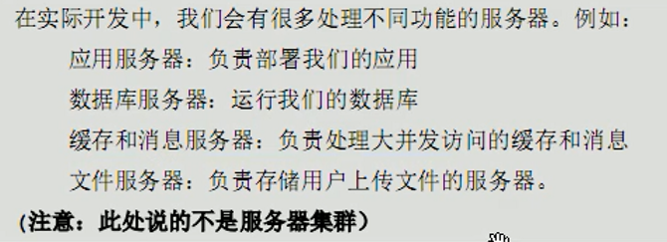

代码见上面

# 异常处理与拦截器

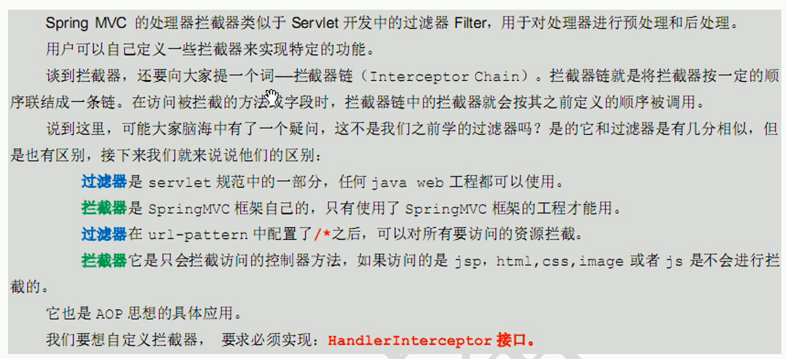

## 简单案例-异常处理思路

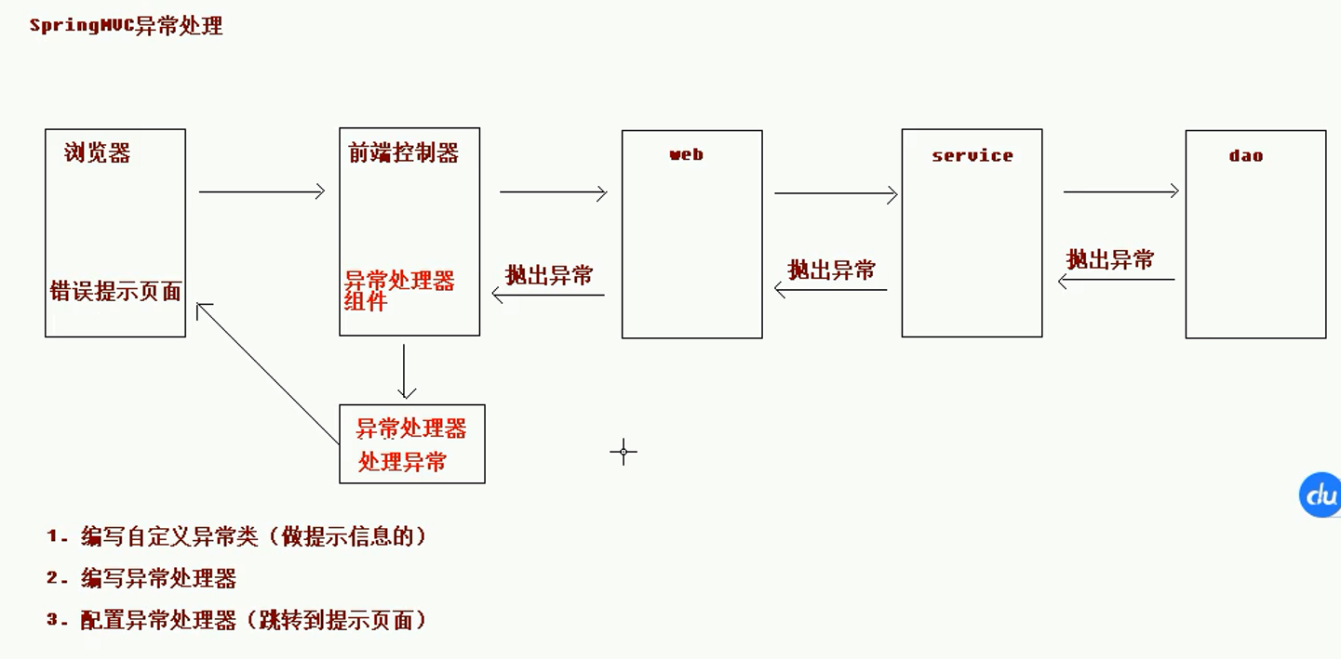

异常代码

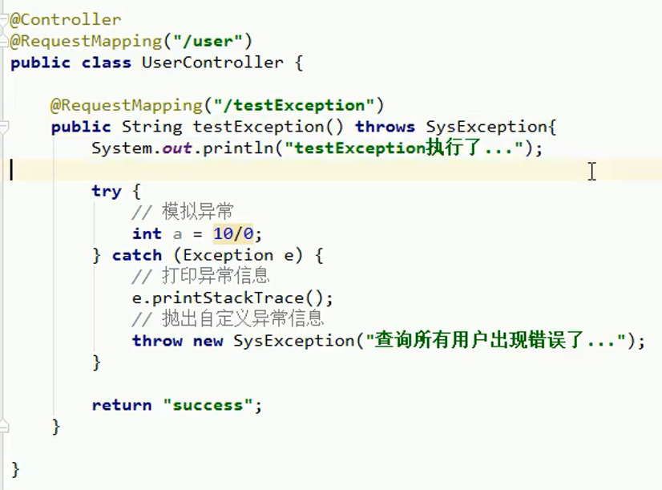

自定义异常

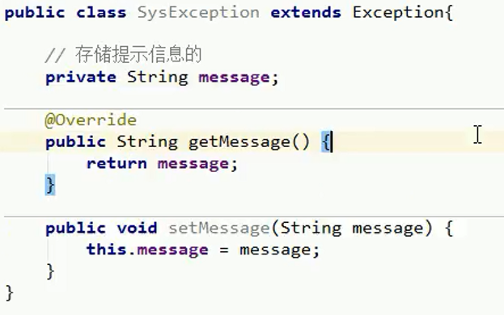

异常处理器

/**

* 异常处理器

*/

public class SysExceptionResolver implements HandlerExceptionResolver{

/**

* 处理异常业务逻辑

* @param request

* @param response

* @param handler

* @param ex

* @return

*/

public ModelAndView resolveException(HttpServletRequest request, HttpServletResponse response, Object handler, Exception ex) {

// 获取到异常对象

SysException e = null;

if(ex instanceof SysException){

e = (SysException)ex;

}else{

e = new SysException("系统正在维护....");

}

// 创建ModelAndView对象

ModelAndView mv = new ModelAndView();

mv.addObject("errorMsg",e.getMessage());

mv.setViewName("error");

return mv;

}

}

SpringMVC配置异常处理器



## SpringMVC异常处理

配置

<!--配置拦截器-->

<mvc:interceptors>

<!--配置拦截器-->

<mvc:interceptor>

<!--要拦截的具体的方法-->

<mvc:mapping path="/user/*"/>

<!--不要拦截的方法

<mvc:exclude-mapping path=""/>

-->

<!--配置拦截器对象-->

<bean class="cn.itcast.controller.cn.itcast.interceptor.MyInterceptor1" />

</mvc:interceptor>

<!--配置第二个拦截器-->

<mvc:interceptor>

<!--要拦截的具体的方法-->

<mvc:mapping path="/**"/>

<!--不要拦截的方法

<mvc:exclude-mapping path=""/>

-->

<!--配置拦截器对象-->

<bean class="cn.itcast.controller.cn.itcast.interceptor.MyInterceptor2" />

</mvc:interceptor>

</mvc:interceptors>

拦截器

/**

* 自定义拦截器

*/

public class MyInterceptor1 implements HandlerInterceptor{

/**

* 预处理，controller方法执行前

* return true 放行，执行下一个拦截器，如果没有，执行controller中的方法

* return false不放行

* @param request

* @param response

* @param handler

* @return

* @throws Exception

*/

public boolean preHandle(HttpServletRequest request, HttpServletResponse response, Object handler) throws Exception {

System.out.println("MyInterceptor1执行了...前1111");

// request.getRequestDispatcher("/WEB-INF/pages/error.jsp").forward(request,response);

return true;

}

/**

* 后处理方法，controller方法执行后，success.jsp执行之前

* @param request

* @param response

* @param handler

* @param modelAndView

* @throws Exception

*/

public void postHandle(HttpServletRequest request, HttpServletResponse response, Object handler, ModelAndView modelAndView) throws Exception {

System.out.println("MyInterceptor1执行了...后1111");

// request.getRequestDispatcher("/WEB-INF/pages/error.jsp").forward(request,response);

}

/**

* success.jsp页面执行后，该方法会执行

* @param request

* @param response

* @param handler

* @param ex

* @throws Exception

*/

public void afterCompletion(HttpServletRequest request, HttpServletResponse response, Object handler, Exception ex) throws Exception {

System.out.println("MyInterceptor1执行了...最后1111");

}

}

多个拦截器同上